CLASS TEST
SUBJECT : MATHEMATICS
CHAPTER : PARALLEL AND INTERSECTING LINES
FULL MARKS :15 TIME : 30 MINUTES
SECTION A
Choose the correct option for the following questions: [6× 1=6]
1. In the below figure, if PQ ‖ RS, then value of a=? (a) 100° (b) 120° (c) 30° (d) 90°
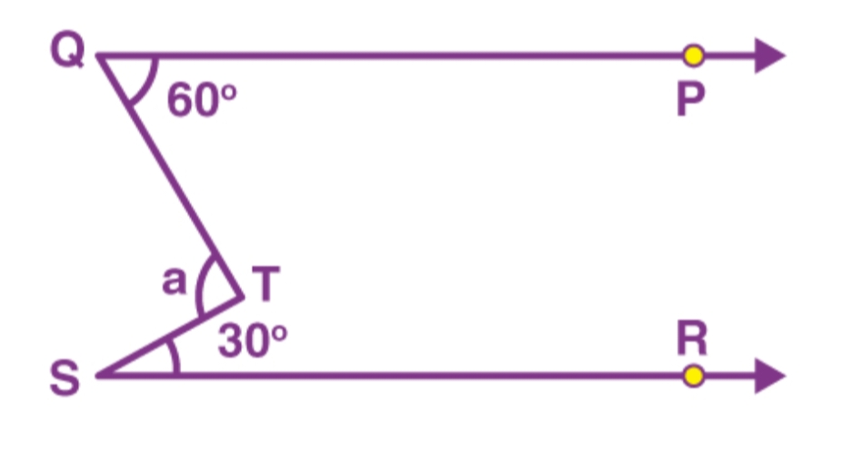
2. Two adjacent angles form a linear pair. If one angle is 57°, the other is
(a) 57° (b) 113° (c) 123° (d) 133°
3. In any adjoining figure, line ‘p’ intersects’ a’ and ‘b’ at two distinct points. How many pairs of vertically opposite angles are formed?
(a) 2 (b) 3 (c) 4 (d) 8
4. When a transversal intersects two non-parallel lines, what is the sum of all four interior angles?
(a) 90° (b) 180° (c) 360° (d) can’t be determined
In the following questions 4 and 5 a statement of assertion (A) is followed by a statement of Reason (R). Choose the correct answer out of the following choices.
(a) Both A and R are true and R is the correct explanation of A.
(b) Both A and R are true but R is not the correct explanation of A.
(c) A is true but R is false.
(d) A is false but R is true.
5. Assertion (A): If a pair of angles will form a linear pair then the pair must also be an adjacent pair.
Reason (R): All adjacent pair will also form a linear pair.
6. Assertion (A): Corresponding angles are equal ⟹ lines are parallel.
Reason (R): Equality of corresponding angles indicates existing of parallel lines.
SECTION B
7. If two lines intersect each other in such a way that the ratio of one such adjacent pair of angles is 2 : 7. Find the four angles. [2]
8. In the given figure, AB ‖ CD and AE ‖ CF. Find the value of x , y and z. [3]
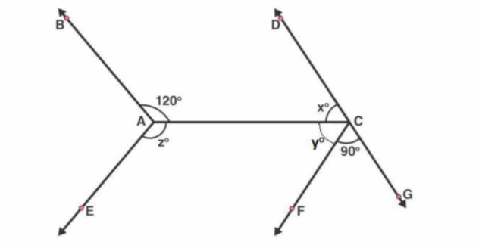
9. If AB ‖ CD ‖ EF , find x. [2]

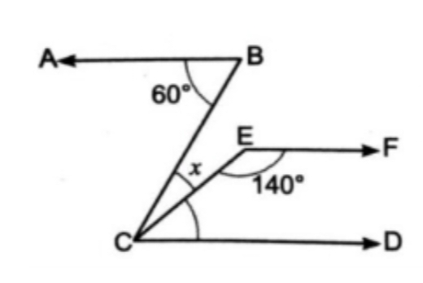
10. Here ‘l₁’ and ‘l₂’ are two lines and ‘t’ is a transversal. Are ∠1 and ∠2 equal? Justify your answer.[2]

